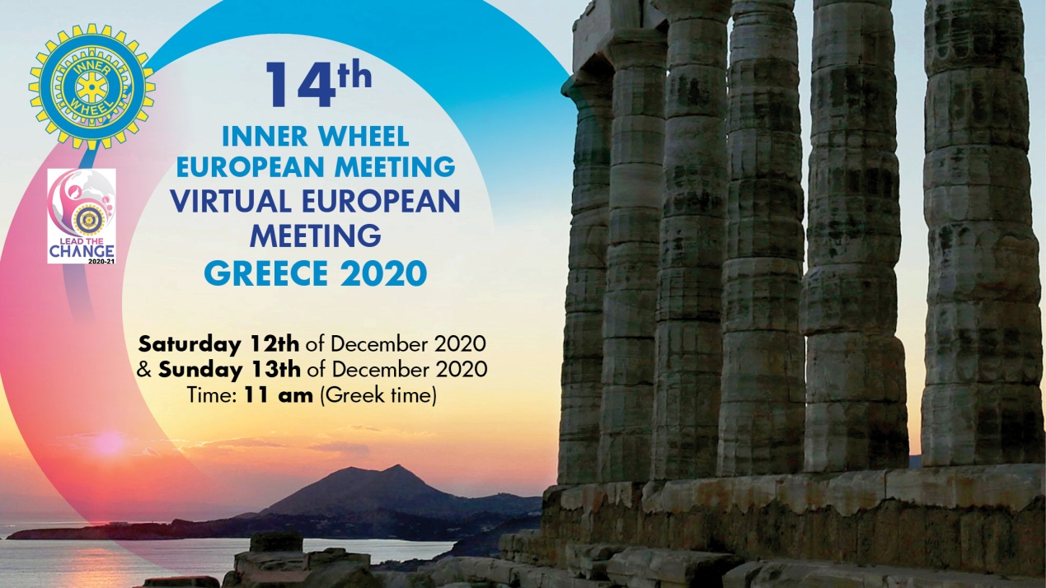
14th (Virtual) IW European Meeting
Greece 2020
12th and 13th December
Time 11.00 am (Greek time)
First Day
Saturday 12th of December 2020
Time 11.00 am (Greek time)
Welcome to the virtual 14th IW EM by National Representative Inner Wheel Greece Gianna Gravia Kalyva
Greetings and information about IIW Convention 2021 by IIW President Dr Bina Vyas
Business Session
Agenda
- 13th Inner Wheel European Meeting –Munster 2019 Comments by the organizers of 13th IW European Meeting in Munster IIWPBD Margareta Momkvist and PNR IW Germany Dr Jutta Stender-Vorwachs
- Introduction of Delegates by the organizer IIWBD Mania Papadopoulou Falidas
European Rally
- European Rally by IIWPP/IIWPT Charlotte De Vos
- 1st IW European Rally, Rotterdam 2019 by the delegates of IW The Netherlands
- 2nd IW European Rally, Berlin 2022 by NR IW Germany Beatrix Von Fassong
Discussion about the growth of European Rally in the future
- European Platform by IIW PPresident Charlotte De Vos
14 YEARS IW EUROPEAN MEETINGS. “Study the past if you would divine the future” Confucius. “Continuity gives us roots; Change gives us branching letting us stretch and grow and reach new heights”
- History of European Meetings by IIW PBD Gabriele Scruempf
- From the spirit of the beginnings to a new European Meeting concept by IIWPBD Luisa Vinciguerra
- All organizers of the past European Meetings are kindly asked to add their opinions and/or experiences
- The delegates of all participants countries are kindly asked to tell their opinion, ideas, proposals on what they expect of the future EMs
Discussion
Future of Inner Wheel in Europe
- European clubs should become a laboratory to revitalize IIW by IIWPP Catherine Refabert
Discussion
Think Tank Workshop
- Is there Democracy in International Inner Wheel? Opening remarks by NR IW Denmark Kirsten Moller
Discussion
Covid 19 Disaster
- By IIW BD Mania Papadopoulou Falidas
- IIW BD Sandra Neretljakovic asked to inform the participants about covid 19 disaster and vaccination fund
New participant country in EMs
- NR of IW Cyprus Tasoulla Voskou will inform us about the projects of IW Cyprus (District 96) in East Mediterranean countries

Second Day
Sunday 13th of December 2020
Time: 11.00am (Greek time)
Constitution-Proposals-Amendments
- IIWIPP Phyllis Charter and IIWCCC Corinne Dalleur will talk about the filling in of “Nomination Forms” and correctly forwarding “Proposals for Convention”
- IIWPP Charlotte De Vos will make an introduction to the discussion on proposals and amendments
- NR IW Denmark Kirsten Moller will comment on the proposals and introduce the proposals and possibly the amendments if they have been sent until a few days before the virtual EM
Each proposal will be read and then an Officer of the IIWGB if this is proposed by IIWGB or the NR of the country if it is proposed by a European Country will kindly asked to speak about the proposal/amendment first and then a discussion will follow
- Open Forum
- 15th IW European Meeting 2021
Meeting Organizers
Gianna Kalyva NR IW Greece
Mania Falidas IIWBD/PNR
Sissy Avgerinou IIWPBD/PNR
Moderator of the Meeting
Sissy Avgerinou
The Organizers warmly thank IIWPBD Gabriele Scruempf who will write the Minutes of the Meeting

