Dear Ladies of IWC Boonah,

Hope you are all well and enjoying this new IW-year. We would so much appreciate having your updates.

It´s such a special year for us with our new IIW President Ingelög Wyndham from Helsingborg, Sweden.
The Change over ceremony was held in Helsingborg June 16 and many members had gathered to celebrate at the Elite Hotel Marine Plaza. “Mission accomplished” when Kay Morland handed over the chain to Ingelög Wyndham! Twenty-four years have passed since we last had a Swedish IIW president.

I Sweden, fall has arrived and the colors of the leaves are beautiful. Now we are looking forward to snuggling up with a book in front of the fireplace. And of course together in the IW Club, dressing in something orange on Orange Day in November.
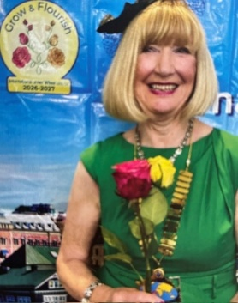
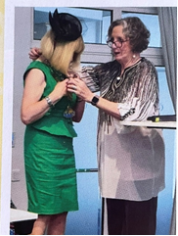
Yours in IW Friendship

Annika Sandén
ISO
IWC Örebro, Sweden

