 | Form for submission of Proposals for Consideration to be presented at the  20th International Inner Wheel Convention, 11-14 May 2027, Manila, Philippines

Each Proposal is to be submitted on a separate FORM.
Please type into the boxes provided. They expand as it fills up. (Or, print, fill by hand, scan and send. Add extra sheets if needed.)
Click and read the GUIDE before filling this Form.
This Form is to be received by 11 November 2025 at International Inner Wheel Headquarters (Email: admin@internationalinnerwheel.org).

PROPOSED BY:
☐ Club or ☐ District or ☐ National Governing Body
Club Name |  |  | Country
District Number |  |  | Non-Districted Club | ☐Yes
National Governing Body Name

SECONDED BY:
☐ Club or ☐ District or ☐ National Governing Body
Club Name |  |  | Country
District Number |  |  | Non-Districted Club | ☐Yes
National Governing Body Name

REFERENCE of the PROPOSAL
Page number
Main heading
Sub-heading (if needed)
Clause number

PROPOSAL:

MOTIVATION: (NOT more than 120 words.)

PRESENTATION at the meeting of the DISTRICT COMMITTEE (for proposals by Clubs with Districts).
Date of meeting [dd/mm/yyyy]
Relevant page of minutes to be attached | ☐ Acknowledge

Signed below by an Executive Officer of the Club, District or National Governing Body which is making this Proposal.
Signature
Last name
Given name
Position

GUIDE TO SUBMISSION OF PROPOSALS

- THIS FORM IS TO BE RECEIVED by 11 November 2025 at International Inner Wheel Headquarters
(Email: admin@internationalinnerwheel.org).
- REFERENCE OF THE PROPOSAL. An example for your understanding, please see below.
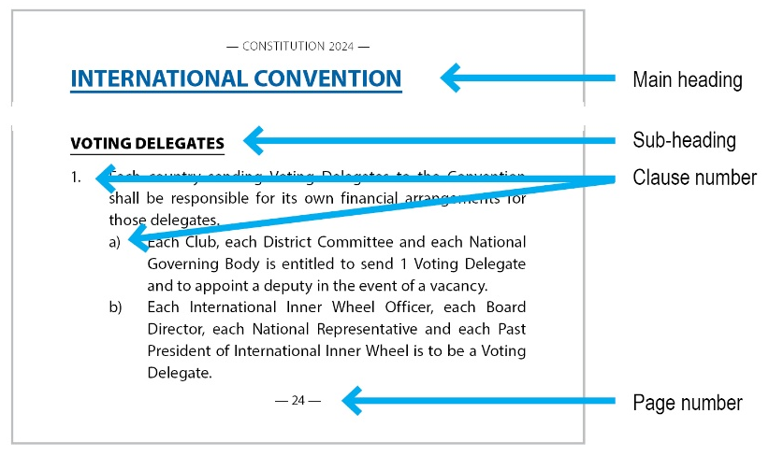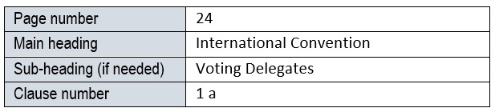
- PRESENTATION at the meeting of the DISTRICT COMMITTEE.
This does not necessarily imply the District has to approve it but means they are aware of it being submitted. A copy of the relevant page in the Minutes of the District Committee meeting is to be attached as evidence.
- CHANGES TO THE CONSTITUTION.
In the event of a dispute, the Chairman of the Constitution Committee will make the final decision.
Extract of the Constitution and Handbook 2024 (Reformatted), pages 28-29.
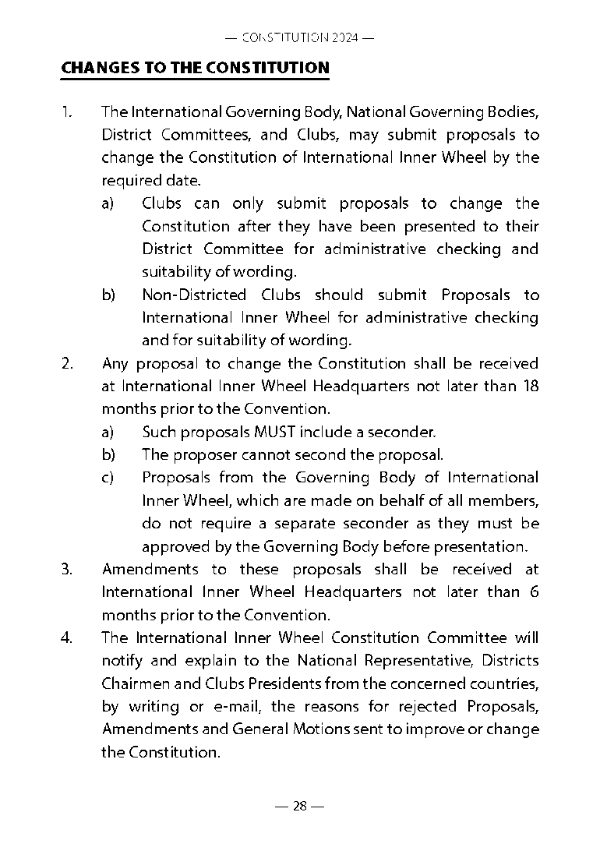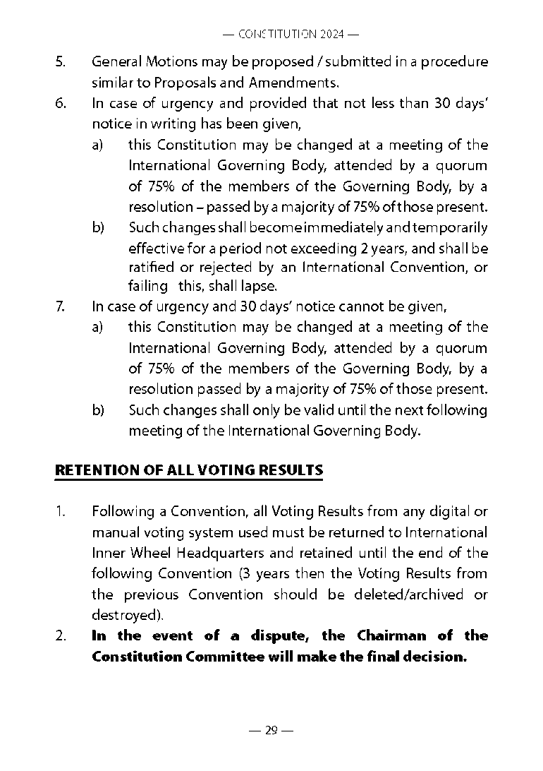

- CONSTITUTION & HANDBOOK 2024 (REFORMATTED).
At the 19th International Inner Wheel Convention 2024 in Manchester, General Motion A was passed by a substantial majority, confirming the need to begin modernising both the language and content of the Constitution and Handbook throughout the 2024-2025 period. The Committee assigned to this important task has completed the process. The Constitution and Handbook 2024 (Reformatted) is now available on the International Inner Wheel website (For Members). This version is the official document and should be used as the reference when submitting any proposals to amend the Constitution.
- A SMALL PROPOSED CHANGE COULD HAVE WIDER CONSEQUENCES.
It is important to examine the Constitution fully to ascertain if a proposal has a bearing on any further aspects of the Constitution. If this is not carried out carefully, and any further references or changes are not included into the proposal, it will result in the proposal being rejected. If a proposal is rejected, the reason for it will be sent to the proposer for further attention. If two or more proposals contain the same subject matter, the proposers will be notified.

- MAXIMISING CONVENTION EFFICIENCY.
During previous Conventions, members expressed a desire for more time to be dedicated to training and workshops. To achieve this goal, it would be beneficial to minimise the inclusion of minor administrative changes as Proposals. These changes can be addressed during the updating of the Constitution and Handbook, allowing members to focus on more meaningful discussions during the Convention.

