Muziek





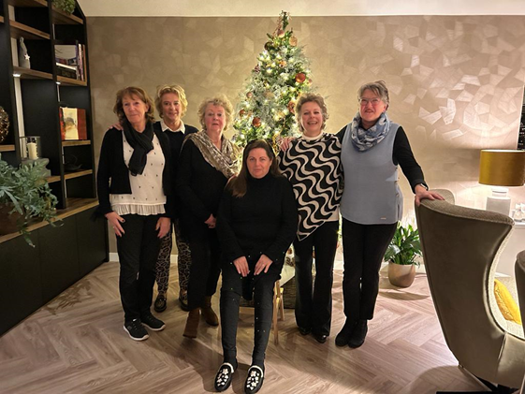

Aalsmeer, December 20th, 2022

Dear Stina and members of Karlshamn Inner Wheel club,

Thank you very much for your kind letter and good wishes.

Indeed the situation in the world is most uncertain although at the moment Covid is not a big problem in the Netherlands but the war in Europe so close to both our countries is getting worse. We do pray that it will end soon and there will be peace in Ukraine.

For the moment our club is doing well with 28 members. Last Wednesday we had our Christmas dinner at a lovely restaurant. This was after two years of ”Christmas Zooming” very agreeable.

All of us wish you a merry Christmas and a happy New Year: 2023.

We will see what 2023 will bring us.

Kind regards,

Inner Wheel Aalsmeer

Joyce Buunk, president

*"Vrouwen luisteren niet naar de woorden, zij luisteren naar de muziek"*

Inner Wheel Aalsmeer | Secretary: Ineke de Wijn e/o Teunie Urlus | The Netherlands | E iiw.nl.aalsmeer@gmail.com